Mended Hearts of Morris County
April 22, 2018 Meeting Update
Greetings to Members and Friends of MHoMC,
On Sunday, our guest speaker was Marnie Sperling; RN, MSM, DMD, who discussed
the topic “Oral Health and Heart Disease”. Marnie received her Bachelor of Science in Nursing at Valdosta State University in 1994. She was awarded a Doctorate of Dental Medicine in 2000 at the University of Medicine and Dentistry of New Jersey. While practicing general dentistry in private practice, Marnie earned her Masters of Nursing
with an emphasis in Forensic Nursing at Monmouth University In 2012. She is a full
time Clinical Assistant Professor at FDU’s Henry P. Becton School of Nursing.
Marnie discussed these topics important to all heart patients:

• The association of oral health and heart disease
• Relationship between oral bacteria and heart plaque
• Understanding periodontal disease
• Guidelines for good oral health
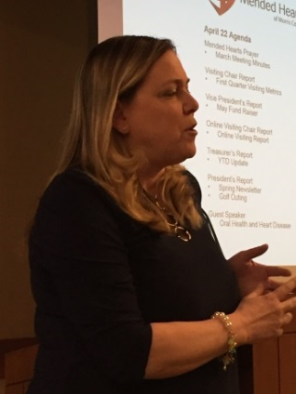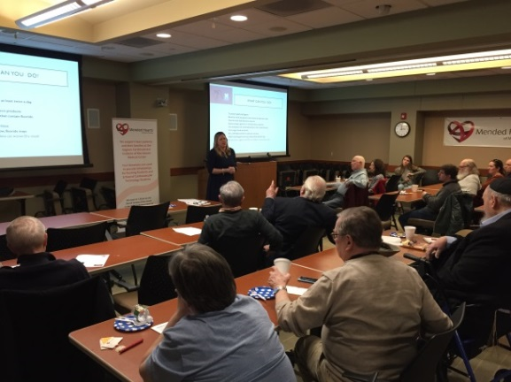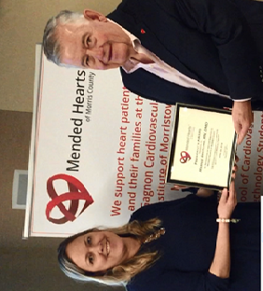

May Meeting
For those who could not be there, I hope you’ll join us on May 20. Our guest speaker will be Dr. Anthony Carrozza discussing Urgent Care and Emergency Room medicine.

Date: Sunday May 20
Time: 1:30 pm to 3:00 pm
Place: Gagnon Cardiovascular Institute, Wilf conference room

© 2018 Mended Hearts of Morris County

