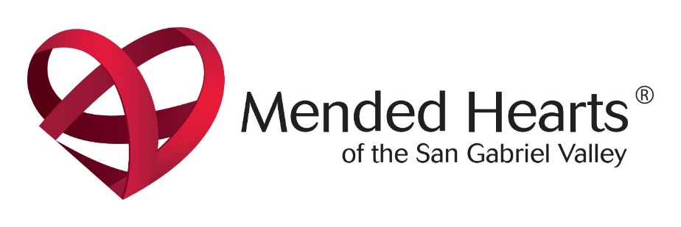
Cardiac Health Support Group Meeting
Mended Hearts is a national support group for all heart patients and their families. Local Mended Heart chapters are located throughout the country. Our Covina chapter offers support group meetings on heart health education with healthcare professionals specializing in cardiac health and mutual support from other heart patients, family members and caregivers.
The next meeting of Mended Hearts Chapter 304 will be held on Tuesday April 11, 2023
We will have a Meet and Greet at 1:00 PM. This will give everyone a chance to meet others with heart related health issues. It’s nice to know you are not alone.
Your story can help others.
The meeting will be held at the
LA FETRA CENTER
333 E. FOOTHILL BLVD.
Glendora, CA 91741
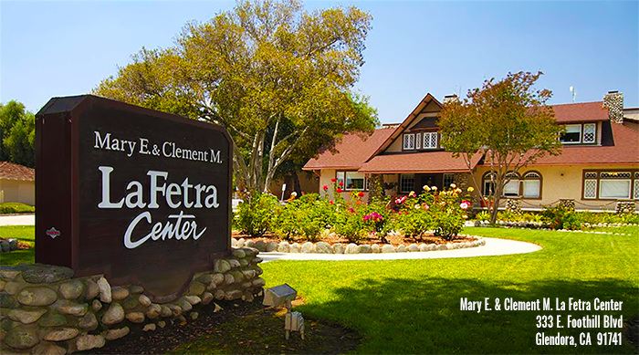
Please call Fred Sparling at 626-893-1014 or email lMendedHearts.Covina.CA@gmail.com

