Home Walking Plan
One benefits of a cardiac rehabilitation program is to help you recognize and understand what is a safe and effective exercise program for you. If you have any questions, be sure to contact St Vincent’s Ascension CardioPulmonary Rehabilitation Program at 205.-939-7139 or Charles.crow@ascension.org
-
IT IS VERY IMPORTANT TO DO A WARM UP AND COOL DOWN EACH EXERCISE SESSION! Start exercising slowly until you warm up and continue to move around slowly (cool down) after your exercise to allow your heart rate to come down gradually. A 5 to 7 minute warm up is recommended. A 5 to 7minute cool down is recommended at the end of your exercise session.

"The Talk test"
You should be able to talk while you exercise. If you cannot carry on a conversation while you exercise, you are going too fast. You should not be able to sing while you exercise. If you can sing, you are going too slow. WALK = TALK.
If your exercise heart rate is too high, slow down or if it is too low, increase your pace. If your cool down heart rate is still high, (greater than 15 beats per minute above resting heart rate) continue to cool down for an additional 3 to 5 minutes. If you have questions, call St Vincent’s Ascension CardioPulmonary Rehabilitation Program at 205.-939-7139 or Charles.crow@ascension.org

Easy Home-Walk Program
Week Time
Week 1-2 5 minutes - 3 x a day
Week 3 7 minutes - 3 x a day
Week 4-5 10 minutes - 2 x day
Week 6-7 12 minutes twice a day
Week 8 20 minutes day
Week 9 30 minutes

Home walking plan

WHEN NOT TO EXERCISE OR STOP EXERCISING! (If you have any of the following.)CALL YOUR DOCTOR IMMEDIATELY!

a. Chest, neck, jaw, teeth, shoulder, or arm pain that is unusual.
b. Too much shortness of breath.
c. Dizziness, nausea, blacking out, or vomiting.
d. Chest pain or discomfort following an activity.
e. Change in stable angina pattern, more frequent, severe, occurs at rest, after meals, or awakens you from sleep.
f. Excessive fatigue that lasts more than an hour after you finish exercising. You should feel recovered 1 hour after exercise.
Skipped beats that appear more frequently than usual.
h. Awaking at night or a need to sleep on more pillows because of shortness of breath.
I. Ankle swelling or continual increase in weight over several days.
j. Unusual joint, muscle, or ligament pain. Home walking plan

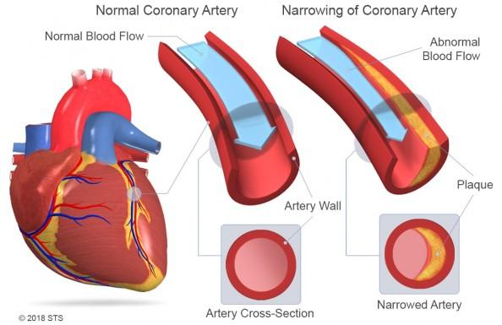
stent
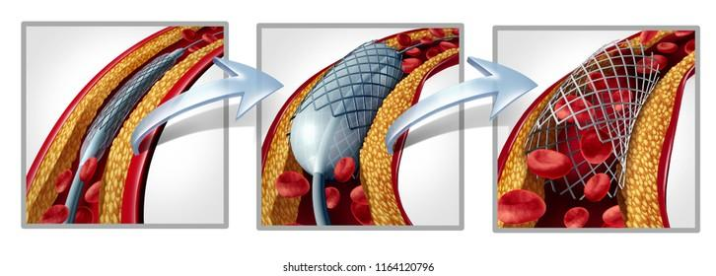
Bypass TAVR Value
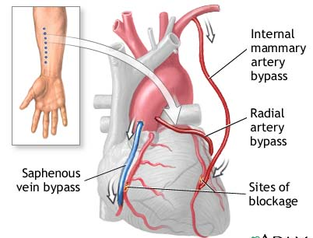 TAVR